ACTIVITY 07 - Total Solar Eclipse in
Queensland – A simulation program.
Year Level: Years 3 to 12 (typically 8 to 18 years of age).

Background: This activity will allow students to investigate the eclipse of the 14th November 2012 and extension activities relating to how the eclipse will vary across Queensland. This activity is to be completed after students have done Activity 04 which is a tutorial to learn the basics of the program Stellarium version 0.11.0. Stellarium is a free software program that is available from the internet at the following site : http://www.stellarium.org/ ..
Aim: To determine the changes in the appearance of the Sun during an eclipse and the duration of Totality as seen from Cairns using the sky simulation program Stellarium and determine the effect of viewing from different locations inside and outside the path of totality.
References:
- Sections 3 and 4 of the AAQ/STAQ teacher booklet.
- PowerPoint presentations PP03 and PP04
- Activity 04 Stellarium Tutorial

Safe Observing Message:
When discussing a solar eclipse students should be reminded that it is not safe to look directly at the Sun at any time and that safe viewing methods must be used to observe a solar eclipse.
Shape of the Australian Curriculum: Science strands on focus areas.

Content descriptors: Year 3, 5, 7 and 10
Science Understanding | Science as a Human Endeavour | Science Inquiry Skills
Yr 3  Earth’s rotation on its axis causes regular changes, including night and day (ACSSU048) | Yr 3  Science involves making predictions and describing patterns and relationships (ACSHE050) | Yr3  With guidance, identify questions in familiar contexts that can be investigated scientifically and predict what might happen based on prior knowledge (ACSIS053)
Yr 5  The Earth is part of a system of planets orbiting around a star (the sun) (ACSSU078) | Yr 5  Science involves testing predictions by gathering data and using evidence to develop explanations of events and phenomena (ACSHE081)  Important contributions to the advancement of science have been made by people from a range of cultures (ACSHE082) | Yr 5  With guidance, pose questions to clarify practical problems or inform a scientific investigation, and predict what the findings of an investigation might be (ACSIS231)
Yr 7  Predictable phenomena on Earth, including seasons and eclipses, are caused by the relative positions of the sun, Earth and the moon (ACSSU115) | Yr 7  Scientific knowledge changes as new evidence becomes available, and some scientific discoveries have significantly changed people’s understanding of the world (ACSHE119) | Yr 7  Identify questions and problems that can be investigated scientifically and make predictions based on scientific knowledge (ACSIS124)  Collaboratively and individually plan and conduct a range of investigation types, including fieldwork and experiments, ensuring safety and ethical guidelines are followed (ACSIS125)
Yr 10  The universe contains features including galaxies, stars and solar systems and the Big Bang theory can be used to explain the origin the universe (ACSSU188) | Yr 10  Scientific understanding, including models and theories, are contestable and are refined over time through a process of review by the scientific community (ACSHE191)  Advances in scientific understanding often rely on developments in technology and technological advances are often linked to scientific discoveries (ACSHE192)  People can use scientific knowledge to evaluate whether they should accept claims, explanations or predictions (ACSHE194) | Yr 10  Plan, select and use appropriate investigation methods, including field work and laboratory experimentation, to collect reliable data; assess risk and address ethical issues associated with these methods (ACSIS199)  Select and use appropriate equipment, including digital technologies, to systematically and accurately collect and record data (ACSIS200)  Use knowledge of scientific concepts to draw conclusions that are consistent with evidence (ACSIS204)  Communicate scientific ideas and information for a particular purpose, including constructing evidence-based arguments and using appropriate scientific language, conventions and representations (ACSIS208)

THE 2012 SOLAR ECLIPSE ACTIVITY

The image below is designed to assist students during the completion of this Activity however students MUST HAVE COMPLETED ACTIVITY 04 before attempting this activity.

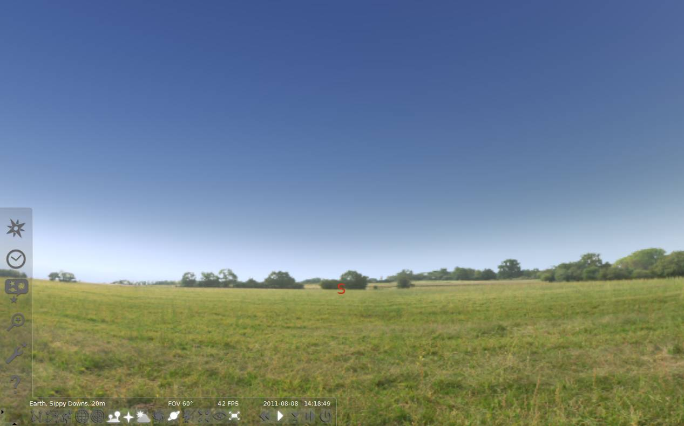
*F
*G
*DD
*E
*C
*B
*AA

Open the location window by clicking on the compass rose on the left pop up tool bar (*A). Type “CAIRNS” in the box with the magnifying glass and then click on Cairns, Australia as it comes up on the list. A red arrow should point to Cairns on the map of Australia. Close this LOCATION box by clicking on the X.
Open the sky and viewing options window (*C) select the Landscape tab and select ocean. This will allow you to see down to the horizon.
Change the date on the left hand side bar to 2012 11 14 and change the time to 5:40:00 (*B ). Close this pop up window. Go to the left hand side bar and click on the magnifying glass (*E). Type in the word “SUN” and press the magnifying glass.

Centre and zoom in on this object (spacebar to centre and roll the mouse wheel or use page up to zoom in) until the glare of the sun disappears.
What do you notice as you zoom in?
____________________________________________________________________________________________________________________________________________________________________________________________________________________________________________________________________________

READ THE NEXT TWO PARAGRAPH IN THEIR ENTIRITY BEFORE CARRYING OUT ANY ACTIONS.
If you want to go forward in time (speed time up) you can press the letter L and this will make time go faster. You can return to normal speed (time) by pressing the K key once. Press the letter L twice and watch what happens. When the moon is about one third of the way across the sun return to normal speed (time) by pressing the K key once. Do this now.
Try going backwards by pressing the J key FOUR TIMES until back to 5:40: 00 (look at the time in the bottom pop up window). Make sure you press the K key to return to normal time. DO NOT PRESS THE L KEY MORE THAN TWICE AND THE J KEY FOUR TIMES (AFTER RETURNING TO NORMAL SPEED), AS IT SPEEDS UP THE DISPLAY TOO MUCH.
Now, try this: One at a time, use the L key (with J and K if needed) move the time forward to that listed above each box in the following pages. Sketch in the box what you see on the screen, using a pencil. You may later apply colour to your sketches.

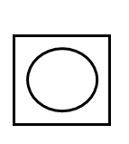
5 : 46 : 30

5 : 45 : 00
6 : 05 : 00

5 : 55 : 00

6 : 25 : 00

6 : 15 : 00

6 : 40 : 25

6 : 35 : 00

6 : 55 : 00

6 : 45 : 00

7 : 15 : 00

7 : 05 : 00

7 : 42 : 00

7 : 25 : 00
1. Calculate and record the duration of the solar eclipse (from the start of the partial phase to the end of the partial phase) based on your diagrams.

The duration is ………………….. (Show how you calculated this.)

Please answer the following questions in complete sentences:
- At approximately what time was the Sun completely covered by the Moon?
______________________________________________________________________________________________________________________________________________________________________________________________________________________________________________________________________________________________________________________
- About how long did the total part of the eclipse last (when the Sun was completely covered by the Moon)? Answer in minutes and seconds and show how you calculated this.
______________________________________________________________________________________________________________________________________________________________________________________________________________________________________________________________________________________________________________________
- Before you did this task, how long did you think eclipses lasted?
Were you correct? Why or why not?
______________________________________________________________________________________________________________________________________________________________________________________________________________________________________________________________________________________________________________________
- What happened to the colour of the sky when the total part of the eclipse was happening?
______________________________________________________________________________________________________________________________________________________________________________________________________________________________________________________________________________________________________________________
- Why do you think that ancient people were so frightened by eclipses?
____________________________________________________________________________________________________________________________________________________________________________________________________________________________________________________________________________________________________________________________________________________________________________________
2. Extension :
- Atherton is another town in the path of totality for the eclipse. Open the Location window (*A) and set the location to Atherton using latitude and longitude positions (Latitude 17 degrees, 16 minutes and 5 seconds South; Longitude 145 degrees, 28 minutes, 28 seconds East). Simmulate the eclipse for the same times as for Cairns and check how long the total part of the eclipse lasts. You are going to have to check the number of seconds. Why is the duration of the total eclipse different from the duration at Cairns? Have a look at the Moon as it covers the Sun. Is it moving over the centre of the Sun or a little to one side? Write an explanation of why the time is different at the two locations.
- Open the Location window (*A) and set the location to Townsville by typing next to the magnifying glass and selecting Townsville from the list. With the date still set to 14 November check what happeneds to the Sun for the same times as in the exercise for Cairns above. Does a total eclipse occur (with the Moon completely covering the Sun)? Find the time of maximum coverage of the Sun and draw a sketch of it noting the time. Estimate what is the maximum percentage of the diameter of the Sun covered.
Now set the location to Rockhampton and then Brisbane. For each place find the time of maximum coverage of the Sun and draw a sketch of it noting the time. Estimate what is the maximum percentage of the diameter of the Sun covered.
Investigate if there is a relationship between the distance from the path of totality and the percentage covering of the Sun.
- Set Stellarium to your location using longitude and latitude positions and use the simulation program to sketch what you will see of the eclipse from your location if viewing with approved Solar Eclipse Observing Glasses or by projection.
3. Research one of the following hot topics of eclipses and prepare a presentation on your selection for a younger primary class:
- myths and legends from different cultures relating to eclipses;
- safe viewing of an eclipse, including the danger of looking at the sun without protection;
- find out where in the world eclipses will occur after 2012 including Total, Annular and Partial Eclipses and what is the difference between them?

